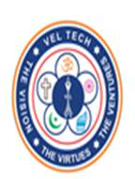
VELTECH RANGA SANKU ARTS COLLEGE
Club of application & development{coad}
VALEDICTORY FUNCTION
DATE : 20 MARCH , 2023
The Bsc department in association with the club of association and development(COAD) ,conducted the valedictory function on 20th of March ,2023. The function was conducted to highlight and encourage the achievements and development of students as well as the club.
FEATURES :
- Award event winners.
- Encourage the participants.
- Badge distribution for successive members of the club.
COMPENDIUM:
Mrs.Reshmi Jeevan was the resource person for the valedictory function. She is an AVP in information security in DLF IT PARK. The guest of honour shared her personal experience about her career and passion. Students were motivated and encouraged to follow their passion.
President report was given about all the events conducted in past one year. Students were introduced to our first edition of student’s magazine named “TECHNOVERSE”. A small teaser of technoverse was released. A tribute video for our honourable principal sir was presented. An AV for badge distribution was presented , where names of the successive members of the COAD was announced.
Later the certificates and medals for the winners were awarded. Awards were given for the following events that are techquest and online events. After the awarding session, paper presentation was given. Power point presentation was given by the students.

INVITATION

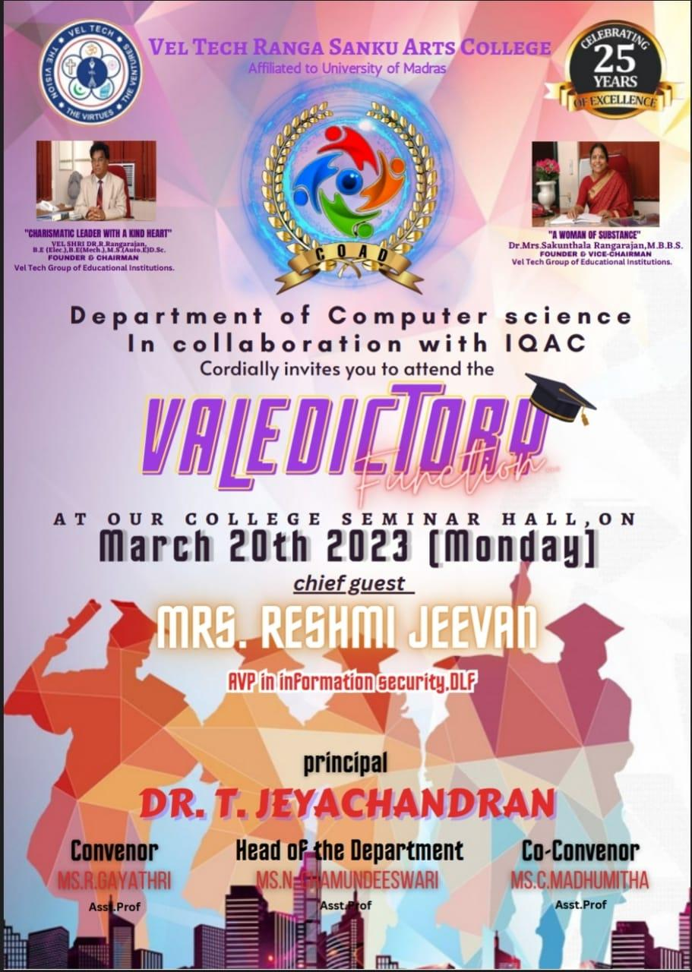

GALLERY

