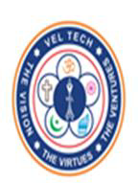
VELTECH RANGA SANKU ARTS COLLEGE
Club of application & development {coad}

THE TECHQUEST CONTEST REPORT
DATE : 2- FEBRUARY-2023 & 3-FEBRUARY-2023
The club of application and development (COAD) had conducted a TECHQUEST on 3rd February,2023. The main ideology was to bring out the technical and non-technical skills in students. The main objective of the club is to make students showcase themselves and participate enthusiastically in every contest.
FEATURES:
- The contest involved Debugging, Quiz and Word building.
- To promote the development of individual talents.
- To develop communication skills.
COMPENDIUM:
The COAD conducted the contest in two phases. The day one of contest was the preliminary round held on 2nd February,2023. Preliminary rounds were conducted only for Quiz and word building to eliminate and select the preferable students. For preliminaries, questions were given on the spot to the students. Individual points were awarded to the students for correct answer. Finalists were selected among them and taken to the next round on day 2.
Day 2 of the contest involved Debugging, Quiz and word building. Individual class was allotted for debugging and the other two contest took place in the seminar hall. Staffs and coordinate members were assigned for every contest held. Printouts were given to the students for debugging the code. Quiz and word building was carried out by shooting questions to the students on the spot. Finally the highest scorer in individual events were selected and announced as winners.

INVITATION

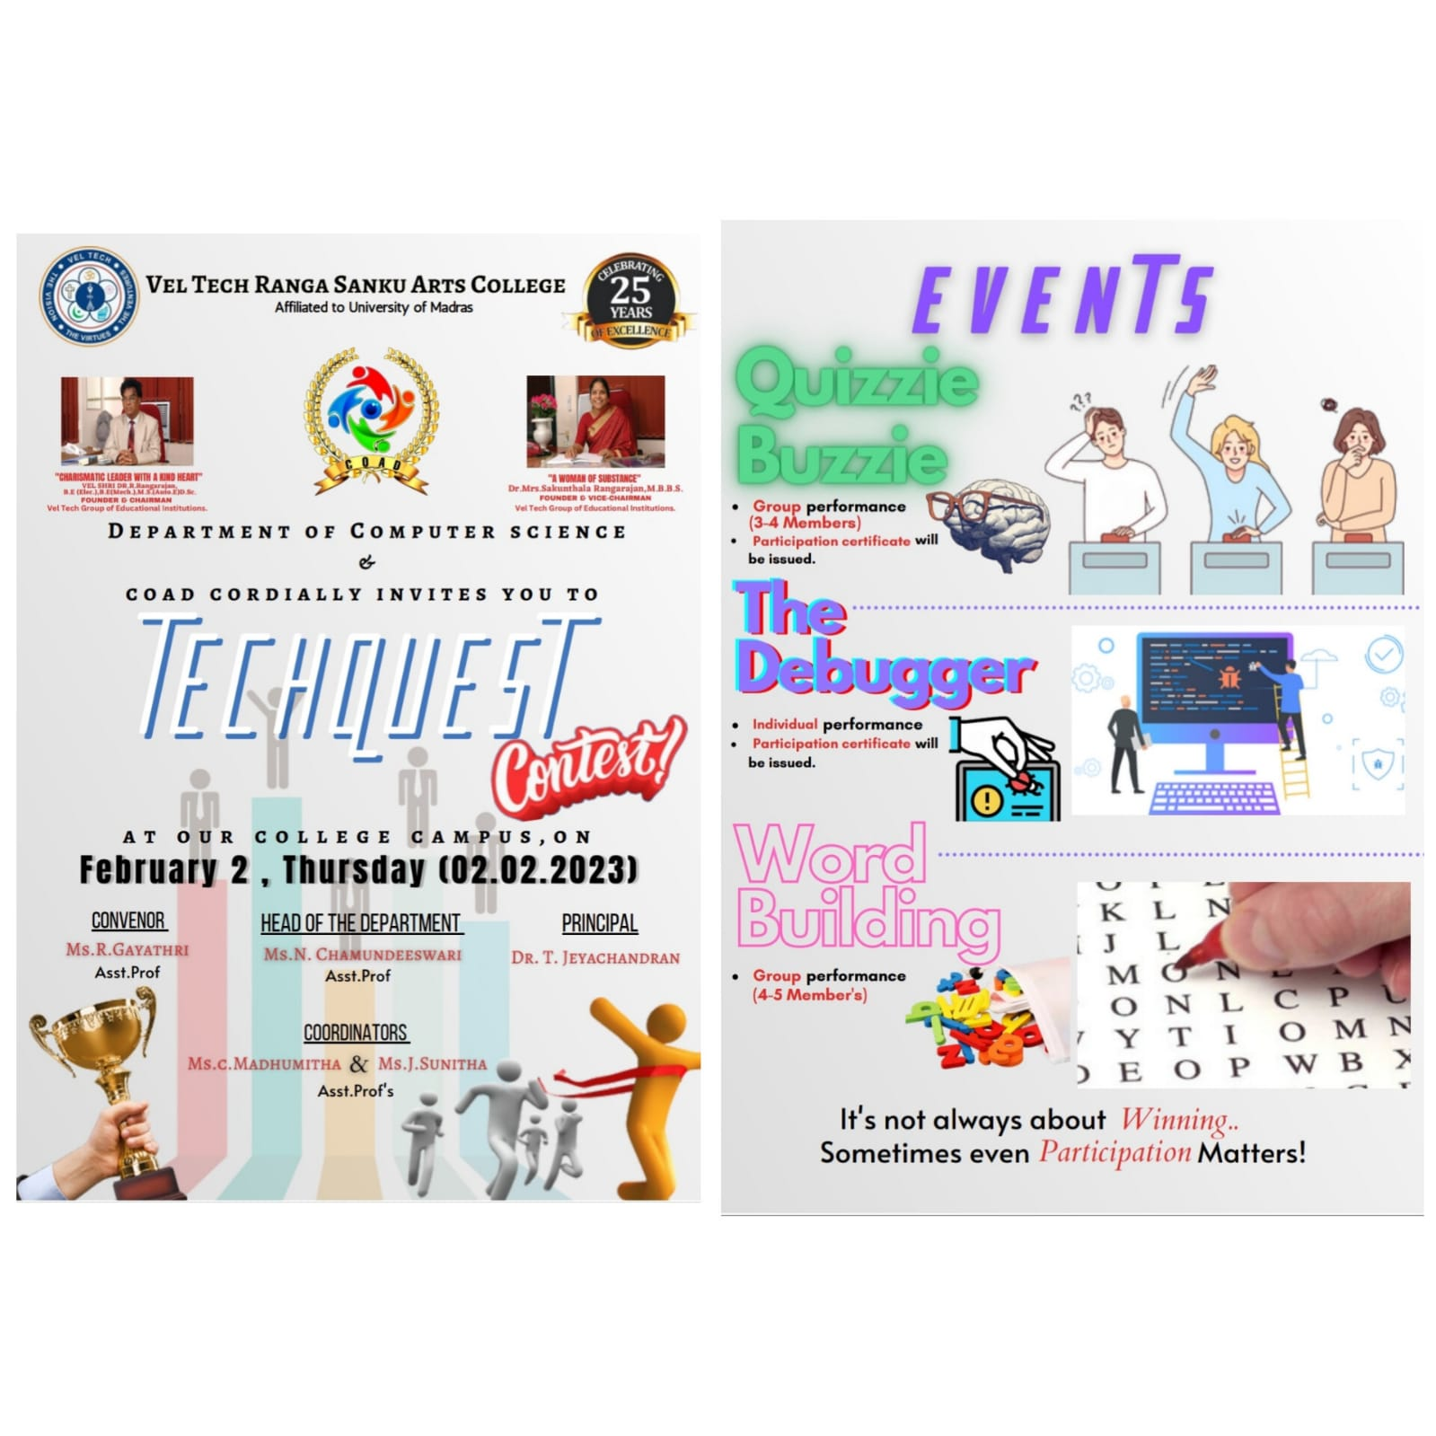

TECHQUEST GALLERY
